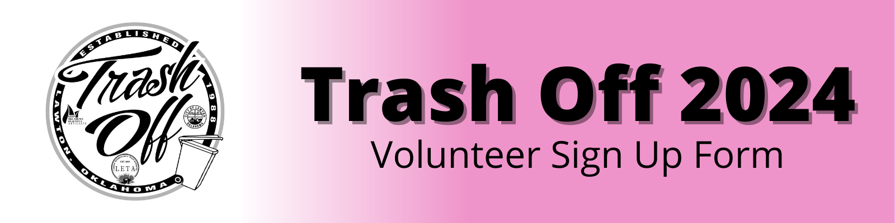

Thank you for choosing to spend time cleaning up our beautiful City on April 6, 2024 from 8 a.m. to 2 p.m.! Please complete the form & return to the City of Lawton. You may email it to joshua.white@lawtonok.gov or return it in person to City Hall at 212 SW 9th Street.

VOLUNTEER ORGANIZATION NAME:
___________________________________________________________________
Point of Contact (First & Last Name):
___________________________________________________________________
Contact Phone Number:
___________________________________________________________________
Contact Email Address:
___________________________________________________________________
Number of Volunteers: _____________
Are any of the organization’s volunteers 16 or younger? ______
What is the organization’s preferred Pickup time between 8 a.m. and 2 p.m. on Saturday, April 6, 2024? _____________________
Does the organization have a preferred cleanup location? If so, where? (Please note that locations are on a first come first served basis.)
___________________________________________________________________

If you have any questions, please do not hesitate to contact Joshua White at (580) 581-3467. We will be in touch upon receipt of your application!

